**Exp. 13 Resource group using Azure**

**Aim:**

To demonstrate Infrastructure as a Service (IaaS) by creating a resources group using a Public Cloud Service Provider (Azure), configure with minimum CPU, RAM, and Storage.

**Procedure:**

* Sign in to Azure Portal
* Click on Create a Resource Group
* Select a name for the Resource group
* Review and finish the setup of resource group

**Output:**

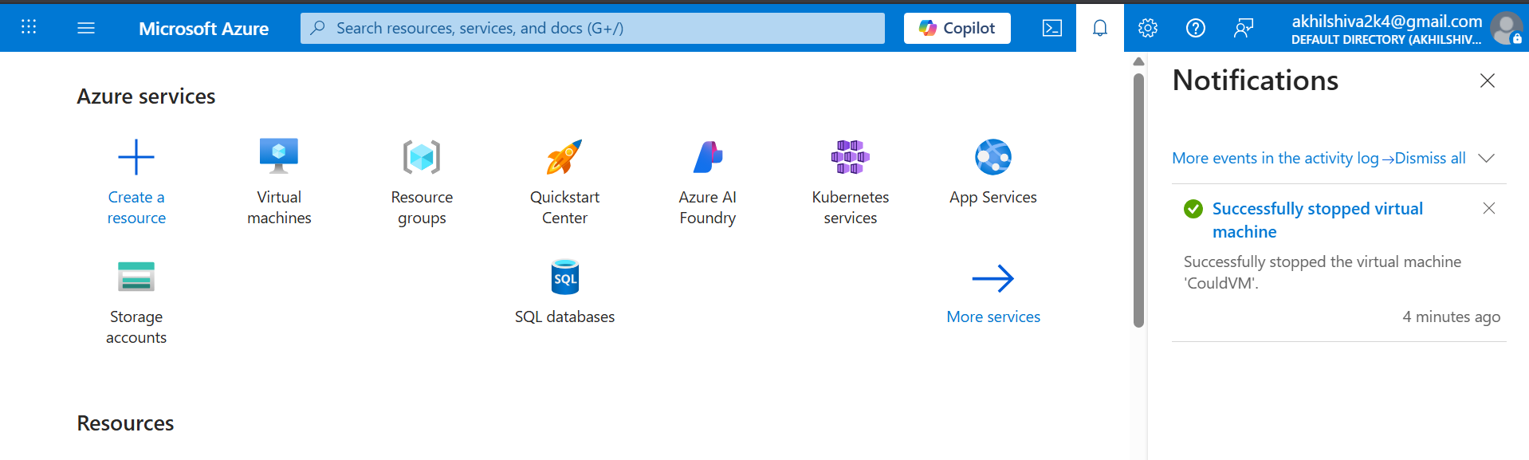

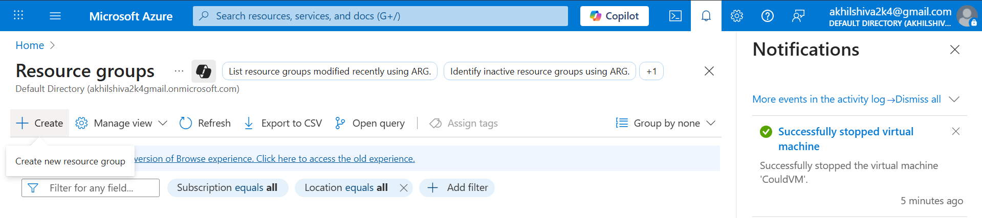

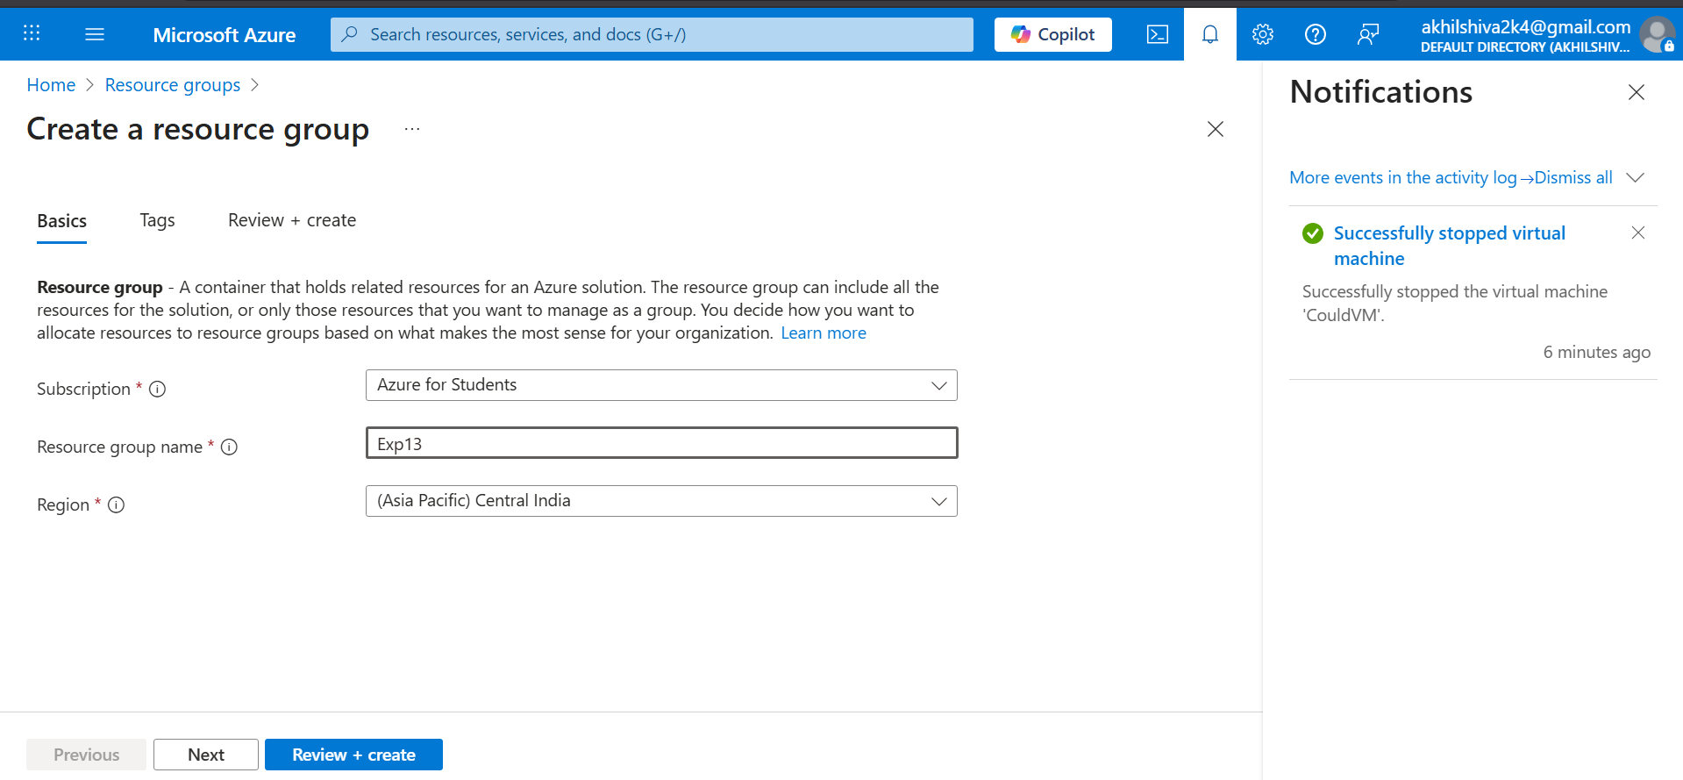

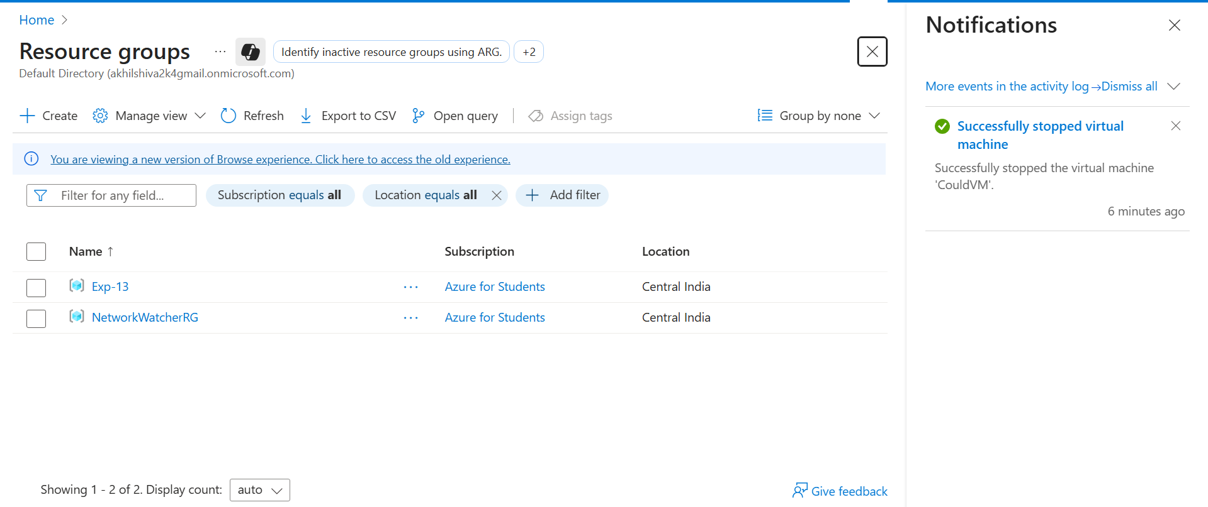

**Result:**

Thus the resource group was created successfully using Azure